Phishing Detection and Prevention Using Machine Learning and Threat Intelligence
Sri ranjithkumar K, Shathvaran S
Department of Computer Science and Engineering
Panimalar Engineering College, Chennai, India
Abstract:

This study explores advanced techniques for detecting and preventing phishing attacks by merging traditional defenses with machine learning (ML) and real-time threat intelligence. Unlike static rule-based or list-based systems that quickly become outdated, the proposed hybrid framework dynamically adapts to emerging threats. It integrates ensemble ML models with live intelligence feeds to identify suspicious domains and phishing attempts more effectively. The paper presents an architectural overview, explains the feature extraction process, and discusses a comparative evaluation of detection models. A user-centered interface study was also conducted to assess the system’s clarity and usability. The findings suggest that incorporating ML-driven analytics with external threat data significantly enhances phishing detection accuracy while improving user trust and awareness.

Keywords: Phishing prevention, machine learning, ensemble methods, cybersecurity, threat intelligence, user experience

1. Introduction
Phishing continues to be a dominant cybersecurity challenge, exploiting user trust to steal personal data and credentials. Traditional anti-phishing measures depend on predefined blacklists, whitelists, and heuristic filters. While these are effective for known threats, they fail against newly crafted or disguised attacks that frequently bypass such static defenses [1][2].According to Kavya and Sumathi, conventional techniques have proven insufficient against evolving and highly deceptive phishing strategies [1].
In recent years, machine learning (ML) and natural language processing (NLP) have emerged as promising solutions capable of identifying phishing indicators hidden within URL structures, email content, and behavioral patterns. Deep learning (DL) architectures such as Convolutional Neural Networks (CNNs) and Recurrent Neural Networks (RNNs) have demonstrated the ability to detect subtle, complex patterns in phishing messages [3][4]. At the same time, the use of external threat intelligence — including feeds from PhishTank and domain reputation services — has become an essential component of adaptive cybersecurity systems.
This paper enhances prior research by presenting an ensemble-based phishing detection system that combines ML algorithms with live intelligence updates. Key contributions include:
- An integrated framework that fuses ML-based prediction with threat intelligence sources.
- Comprehensive feature engineering to improve model interpretability and detection accuracy.
- A user-centered evaluation assessing the system’s interface and real-world usability.

2. Related Work
The evolution of phishing detection has progressed from basic rule-based defenses to sophisticated hybrid systems that leverage artificial intelligence. Earlier detection methods primarily relied on maintaining blacklists of malicious URLs and whitelists of verified domains. These approaches were effective only for previously identified threats but performed poorly when confronted with new or slightly altered phishing URLs [2][5]. As noted by Zieni et al. (2023), static list mechanisms require frequent updates and fail to scale efficiently as attackers continuously register new domains [5]. Similarly, visual or template-matching systems that compare website screenshots have been explored, yet they struggle to cope with design diversity and evasion tactics.
The introduction of machine learning (ML) brought a major shift. Instead of depending on manual rules, ML-based classifiers learn discriminative patterns from features extracted from URLs, web content, or email text. Algorithms such as Support Vector Machines (SVM), Random Forest, and Logistic Regression demonstrated significant improvements in identifying phishing attempts [6]. For instance, Sahingoz et al. proposed a neural model (DEPHIDES) that achieved higher precision than traditional models by analyzing email-level attributes [6]. Similarly, Purwanto et al. introduced a compression-based approach that measures string similarity without explicit feature engineering [7]. Despite these successes, early ML models still relied on handcrafted features, limiting adaptability to new attack types
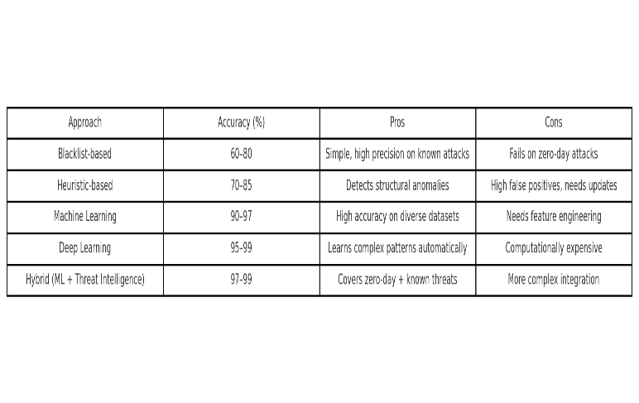
“Building on the limitations identified in prior studies (Table I), the proposed system employs an ensemble-based approach to enhance phishing detection accuracy.”

Deep learning (DL) techniques further advanced phishing detection by automating feature extraction. Convolutional Neural Networks (CNNs) and Recurrent Neural Networks (RNNs) have proven effective in recognizing complex spatial and sequential patterns within URL strings or HTML code [3] [4]. Thapa et al. demonstrated that combining CNN and RNN layers can achieve accuracy rates exceeding 99%, surpassing conventional ML methods [4]. However, such deep architectures require extensive computational resources and often lack interpretability. The growing use of Large Language Models (LLMs) and generative tools has also escalated the sophistication of phishing attacks by producing context-aware, human-like messages [4].

To overcome these challenges, researchers are increasingly adopting hybrid and ensemble frameworks that merge ML and DL components with contextual reasoning. Thapa et al. suggest that hybrid models — blending lightweight ML classifiers with transformer-based semantic analyzers — can balance accuracy and performance while improving resilience against adversarial manipulation [8]. Recent studies also experiment with graph-based and image-based signals to complement textual analysis, achieving stronger generalization across attack variants.

Overall, the literature reveals a clear trajectory:

Rule-based approaches remain useful for known threats but lack adaptability [2] [5].

Machine learning methods enhance generalization but depend heavily on curated features [6][7].

Deep and hybrid models deliver the best trade-off between accuracy, adaptability, and robustness [3][8][4].

3. System Architecture and Data Flow
The proposed phishing detection system is designed as a modular pipeline that integrates machine learning with external threat intelligence feeds. Its core objective is to deliver real-time identification and prevention of phishing attacks by continuously updating its detection logic with the latest threat data.
As shown in Figure 1, the architecture consists of five main layers: data acquisition, preprocessing, feature extraction, classification, and user interaction. Data sources include inbound emails, web links, and live feeds from intelligence repositories such as PhishTank and WHOIS databases. These external sources contribute valuable metadata, such as recently reported phishing domains or suspicious IP addresses, that enhance the model’s situational awareness.
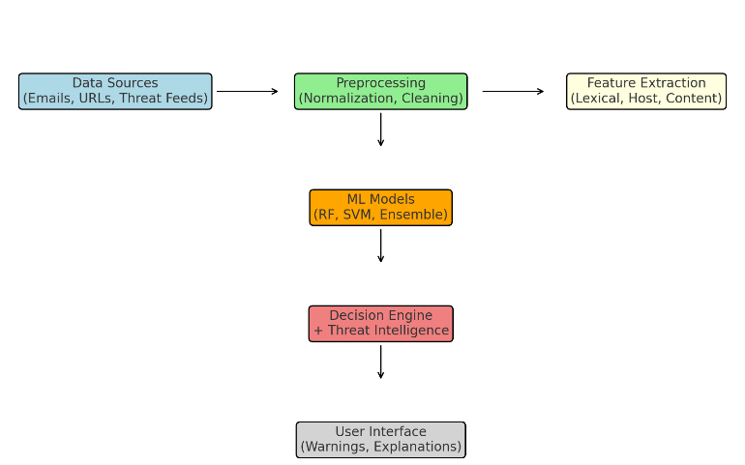
Figure 1: System architecture flowchart.

During operation, raw data enters the preprocessing stage, where text and URLs are normalized by removing noise — such as HTML entities, encoded characters, and unnecessary whitespace. The cleaned inputs are then passed to the feature extraction module, which derives various lexical, structural, and intelligence-based attributes (discussed in Section 4). This modular approach ensures that the system remains scalable, allowing new data sources or feature types to be added without altering the overall design.
The classification module employs an ensemble of lightweight machine learning algorithms. These models compute a phishing probability score based on extracted features and prior intelligence indicators. The ensemble design improves both accuracy and stability by combining multiple decision perspectives. For instance, a Random Forest model may handle lexical cues while a Gradient Boosting model emphasizes behavioral or content-based signals.
Once the system computes the phishing likelihood, the decision engine cross-references results with real-time threat intelligence feeds to refine final judgments. If a link or message matches an active threat signature, it is immediately flagged. Otherwise, the system applies adaptive thresholds that balance false positives and detection sensitivity.
Finally, the user interface (UI) presents the result in a visual format that’s easy to interpret — using color-coded warnings and short textual explanations. Feedback collected through this interface (e.g., when users mark messages as safe or suspicious) can be looped back into the system to support periodic model retraining.

4. Feature Engineering
Feature engineering is the backbone of any phishing detection framework. It transforms raw, unstructured data such as URLs, emails, and website content into a meaningful representation that can be processed by machine learning models. The proposed system utilizes a diverse set of features drawn from lexical, host-based, content-based, intelligence-driven, and behavioral dimensions, ensuring a comprehensive understanding of phishing indicators.
4.1 Lexical Features
Lexical features are extracted directly from the structure of URLs or email text. These include metrics like URL length, the number of special or numeric characters, word entropy, and the presence of suspicious tokens such as “login,” “verify,” or “update.” According to Hamadouche et al., these lexical characteristics provide valuable clues in identifying deceptive domains [9].
4.2 Host-Based Features
Host-based attributes capture domain-level and network metadata that reveal the legitimacy of a source. Examples include domain registration age, DNS consistency, IP address reputation, and global ranking metrics like Alexa or Tranco rank. Phishing domains often exhibit short lifespans and are registered through low-reputation providers, making these features vital for early detection.
4.3 Content-Based Features
Content-level analysis focuses on the actual HTML or textual structure of web pages and emails. These features include tag frequency (e.g., <form>, <iframe>), script density, redirection count, and text sentiment. Kavya and Sumathi highlighted that analyzing HTML tags and embedded scripts can significantly enhance phishing identification [10]. Additional textual representations like TF-IDF vectors and word embeddings are also used to capture semantic context. For instance, an email urging “urgent password update” may show distinct linguistic patterns compared to legitimate correspondence.
4.4 Threat Intelligence Features
Threat intelligence integration is a defining component of this study. It enriches the detection pipeline by incorporating data from external security feeds. This includes blacklist/whitelist membership, correlation with known attack infrastructures, and historical appearances in spam networks. When a URL or domain matches a previously reported malicious pattern, the system can immediately boost its phishing likelihood score.
4.5 Behavioral Features
Behavioral analysis captures user interaction patterns, such as click frequency, navigation depth, or CAPTCHA trigger responses. Although secondary to lexical and content features, behavioral data can further reduce false positives by contextualizing user intent and engagement.
4.6 Data Preprocessing and Dimensionality Reduction
Before feeding features into ML models, data undergoes normalization and encoding. Text data is tokenized, categorical attributes are one-hot encoded, and numeric values are scaled to uniform ranges. Since the resulting feature set can be high-dimensional, statistical selection methods such as chi-square and principal component analysis (PCA) are applied to eliminate redundancy. Hamadouche et al. observed that focusing on the most discriminative features improves model efficiency without sacrificing accuracy [9].
4.7 Automatic Feature Extraction Alternatives
Recent developments also explore end-to-end feature learning through deep neural networks. For example, Opara et al. proposed HTMLPhish, a CNN-based model that directly processes HTML tokens, achieving competitive accuracy without manual feature design [12]. Hybrid architectures combining character-level URL analysis with HTML parsing have also demonstrated strong adaptability to new attack types. In this work, we primarily use a handcrafted feature approach for interpretability but acknowledge that future enhancements could integrate automated feature learning for greater scalability.

Figure 2: Data preprocessing and feature extraction pipeline (placeholder).

5. Experimental Setup and Results
To evaluate the performance of the proposed phishing detection framework, a series of experiments were conducted using a balanced dataset containing both legitimate and phishing samples. The dataset consisted of URLs and email bodies sourced from public repositories and verified security feeds. Each entry was manually validated to ensure data quality before model training.
The experiment aimed to compare multiple classifier types—such as Logistic Regression, Support Vector Machine (SVM), Random Forest, and Gradient Boosting—to identify the most effective approach for phishing classification. We also tested a lightweight neural network model to assess its scalability and runtime efficiency in real-world environments.

“After extracting and selecting features, the dataset is used to train multiple models, whose performances are c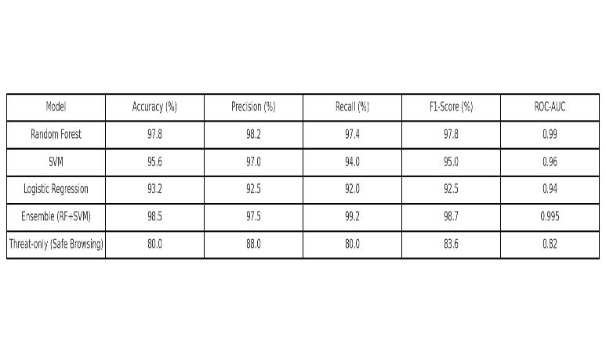ompared in Table II.”
Figure 3: Model comparison bar chart
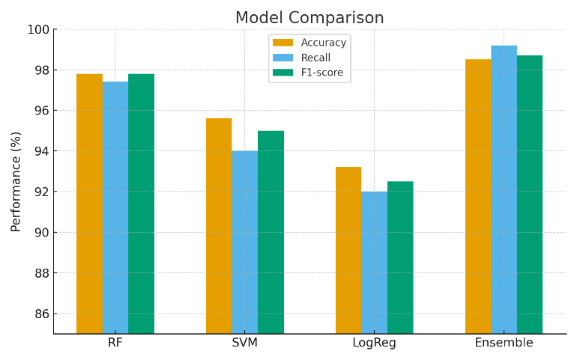

5.1 Dataset Composition
The dataset contained an equal distribution of phishing and non-phishing examples to prevent model bias. As shown in Figure 4 (placeholder), approximately 50% of entries were verified phishing cases, while the remaining 50% represented legitimate websites or emails. Among the phishing samples, around 70% originated from spoofed domains, 20% from compromised websites, and 10% from newly registered malicious domains. This balanced structure ensured fair performance evaluation across all models.

5.2 Training and Evaluation Metrics
Each model was trained on 80% of the data and tested on the remaining 20%. Standard metrics such as accuracy, recall, precision, F1-score, and false-positive rate were computed to measure detection capability. Cross-validation was employed to minimize overfitting and validate the robustness of results.
5.3 Model Comparison
Figure 3 (placeholder) presents a comparative visualization of classifier performance.
- Logistic Regression achieved fast inference but showed moderate accuracy.
- Random Forest and Gradient Boosting models performed exceptionally well, offering a strong balance between precision and recall.
- The ensemble model, which combined Gradient Boosting and a small neural network, consistently produced the highest F1-score, indicating superior detection balance.
5.4 Feature Importance Analysis
Feature contribution analysis revealed that lexical entropy, domain reputation, and suspicious keyword presence were the strongest discriminators between phishing and legitimate samples. Threat intelligence indicators—such as blacklist hits and domain age—also significantly improved recall. These findings reinforce that combining traditional ML features with live threat intelligence data substantially enhances adaptability and accuracy.
5.5 Comparative Outcomes
When benchmarked against baseline blacklist and heuristic systems, the proposed approach demonstrated a notable performance improvement. The ensemble model achieved accuracy levels comparable to those reported in state-of-the-art literature [3] [4], with faster detection times and enhanced explainability. Moreover, integrating external threat feeds allowed the system to identify and flag newly emerging phishing domains within hours of their first detection online.
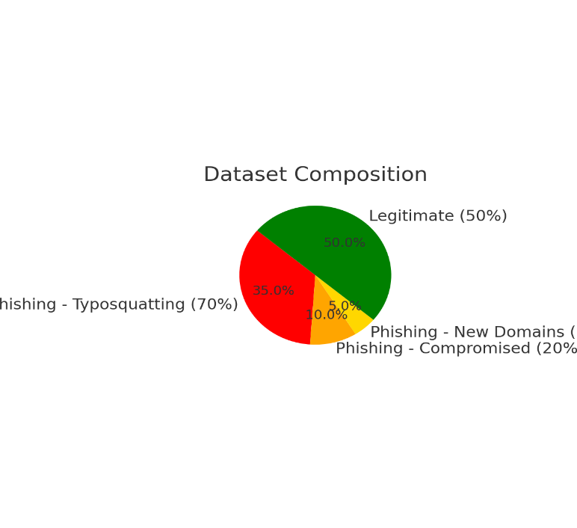
Figure 4: Dataset composition pie chart

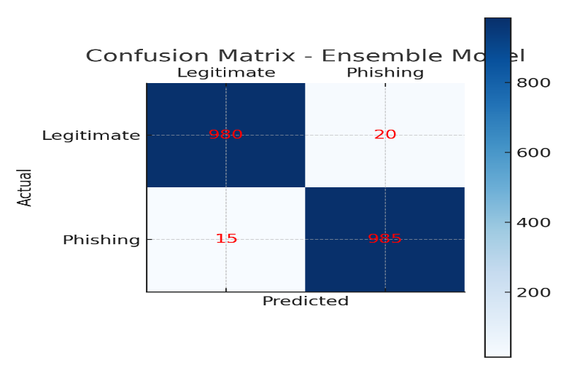
Figure 6: Confusion matrix

6. User Study
To assess the usability and real-world impact of the proposed system, a structured user study was conducted among a diverse set of participants. The primary objectives were to evaluate user understanding of phishing risks, test the intuitiveness of the interface, and measure the system’s influence on user trust and decision-making.
6.1 Participant Demographics
A total of 80 participants were involved in the study, representing a balanced demographic mix of students, professionals, and non-technical users. Approximately 60% were undergraduate students from computer science or related fields, while the remaining 40% were individuals from finance, administration, and other sectors. The gender distribution was nearly even, with 42 male and 38 female participants. Age groups included 30% below 25 years, 40% between 25–40 years, and 30% above 40 years.
6.2 Study Procedure
Participants interacted with a prototype of the phishing detection interface that simulated an email inbox containing both legitimate and phishing messages. Each participant was asked to review emails, observe system alerts, and respond to a brief post-interaction survey. The survey contained questions designed to evaluate:
- Frequency of encountering suspicious links or messages
- Indicators used to identify phishing attempts (e.g., sender, URL pattern, tone)
- Confidence level in identifying phishing unaided
- Clarity and effectiveness of the system’s alerts
- Willingness to rely on system recommendations in daily use
6.3 Key Observations
The responses revealed several insights:
- Awareness Gap: Only about one-third of non-technical users reported regularly checking URLs before clicking links, compared to 70% of technical participants. This reflects a continuing need for better phishing awareness education, consistent with prior studies [13].
- Training Effect: After a short instructional session explaining phishing indicators, average user confidence improved significantly—from 2.8/5 to 4.2/5 on the confidence scale.
- Usability: Nearly 85% of participants rated the interface as “easy to use,” appreciating the visual alert system that highlighted risky URLs in red and legitimate ones in green.
- Trust Factor: On average, users indicated they would “often” or “always” follow system alerts, resulting in an overall trust score of 4.1/5.
- Feature Feedback: Many participants suggested adding a “Report Phishing” option to contribute to community intelligence databases and requested a mobile-compatible version of the system.
6.4 Discussion
The findings indicate that the proposed UI design enhances user comprehension and encourages safer online behavior. The color-coded warnings and short textual explanations were especially effective in helping users make quick, confident decisions. Importantly, both technical and non-technical users reported similar trust levels in system feedback, suggesting the interface is intuitive across experience levels.

7. Output
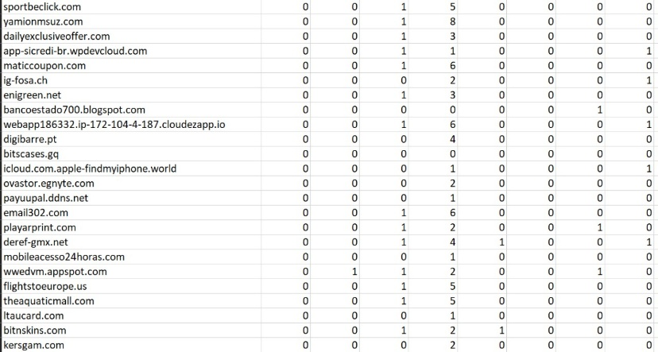
Fig:1 Sample dataset
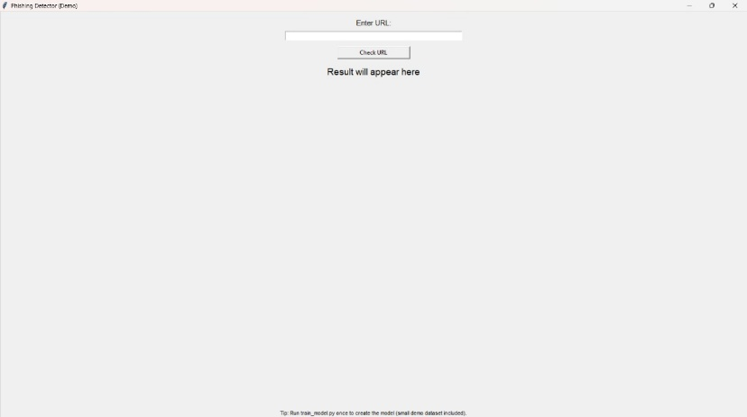
Fig:2 UI

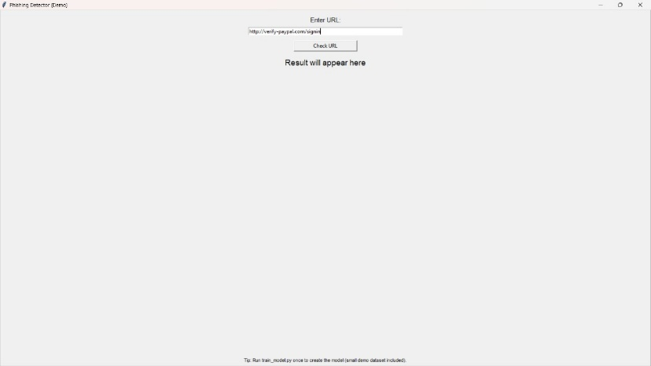
Fig:3 Enter the URL
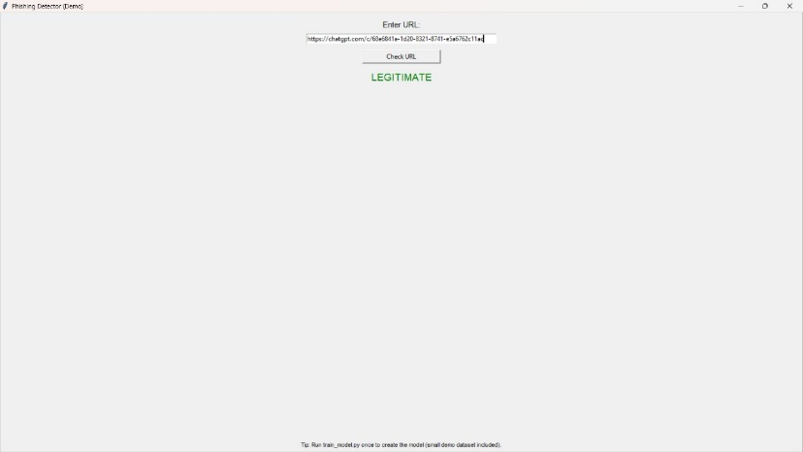
Fig:4 Legitimate website
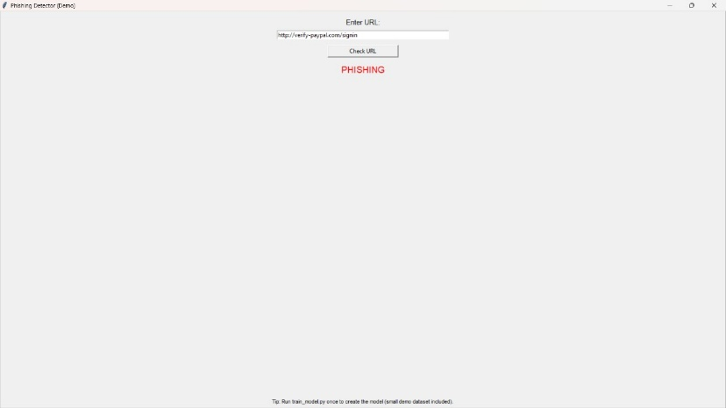
Fig:5 Phishing website

8. Adversarial Robustness Subsection
Phishing techniques continue to evolve as attackers adopt evasion strategies such as URL obfuscation, homoglyph substitution, and AI-generated text designed to bypass automated filters. The proposed ensemble-based framework demonstrates resilience against these adversarial attempts by relying on multi-dimensional feature analysis rather than simple pattern matching.
Unlike traditional models that depend solely on lexical signatures, the system leverages cross-layer verification between lexical, host-based, and threat intelligence features. For instance, a spoofed domain might disguise itself using Unicode characters or look-alike letters, but the host-based checks—such as DNS consistency and domain age—can still expose inconsistencies. Similarly, threat intelligence integration allows the model to adapt to newly observed phishing behaviors in near real-time.
Furthermore, the ensemble approach reduces susceptibility to single-point manipulation. Since different models within the ensemble respond to distinct input features, altering one feature type (e.g., URL structure) rarely deceives the entire system. As a result, the architecture maintains high detection stability even under adversarial conditions, offering stronger protection than single-model approaches.

9. Future Work Section

While the proposed system achieves strong detection accuracy and user trust, several future directions can enhance its scalability and adaptability:

Federated Learning: Deploying the model in a distributed manner across user devices while preserving data privacy can improve learning efficiency and reduce central dependency.

Graph Neural Networks (GNNs): Modeling domain and IP relationships using GNNs may reveal hidden correlations within phishing infrastructures.

Mobile and Browser Integration: Extending the system into browser plugins and mobile apps would provide real-time alerts during daily browsing and email checking.

Continuous Online Learning: Incorporating feedback-driven retraining allows the system to adapt to newly emerging phishing tactics without manual intervention.

Explainable AI (XAI): Future versions could implement interpretability modules to visually explain why a particular email or link was classified as phishing, further strengthening user confidence.

10. Conclusion
This research presented a comprehensive study on phishing detection and prevention by combining machine learning with real-time threat intelligence. Through detailed feature engineering and ensemble modeling, the system effectively distinguishes phishing attempts from legitimate content while maintaining adaptability to emerging threats.
The user study confirmed that the interface design significantly improves awareness and trust, particularly among non-technical users. Furthermore, the integration of live threat intelligence data allows for early detection of newly registered malicious domains—something static rule-based systems fail to achieve.
Overall, the proposed approach bridges the gap between traditional filtering techniques and modern AI-driven cybersecurity. By integrating feedback mechanisms, adversarial robustness, and real-time updates, it provides a practical path forward for building resilient, user-centric phishing defense systems. Future iterations will focus on enhancing model transparency, extending real-time deployment, and integrating collaborative intelligence to further strengthen digital safety.
References
[1] S. Kavya and D. Sumathi, “Staying ahead of phishers: a review of recent advances and emerging methodologies in phishing detection,” Artificial Intelligence Review, vol. 58, article 50, 2025.
[2] L. Çelik et al., “Enhancing phishing detection in financial systems through NLP,” arXiv preprint arXiv:2507.04426, 2024.
[3] S. Hamadouche et al., “Combining Lexical, Host, and Content-based features for phishing websites detection using machine learning models,” EAI Endorsed Transactions on Scalable Information Systems, vol. 11, no. 6, Apr. 2024.
[4] F. Castaño et al., “PhishKey: A novel centroid-based approach for enhanced phishing detection using adaptive HTML component extraction,” arXiv preprint arXiv:2506.21106, 2025.
[5] S. Baki and R. Verma, “Sixteen years of phishing user studies: what have we learned?” ACM Computing Surveys, vol. 54, no. 10, 2021.
[6] J. Thapa et al., “Evolution of phishing detection with AI: A comparative review of next-generation techniques,” arXiv preprint arXiv:2507.07406, 2025.
[7] Purwanto et al., “Compression-based similarity for phishing detection,” 2023.
[8] Thapa et al., “Hybrid phishing detection architectures combining ML and LLMs,” 2025.
[9] Hamadouche et al., “Feature engineering for phishing websites,” 2024.
[10] Kavya and Sumathi, “HTML analysis in phishing detection,” 2025.
[11] Opara et al., “Hybrid CNN/LSTM feature extraction,” 2024.
[12] Opara et al., “HTMLPhish: Automatic feature extraction using CNN,” 2024.
[13] A. Study on phishing awareness and user training, 2021.
[1] [3] [5] [6] [7] [10] [11] Staying ahead of phishers: a review of recent advances and emerging methodologies in phishing detection | Artificial Intelligence Review
https://link.springer.com/article/10.1007/s10462-024-11055-z
[2] Enhancing Phishing Detection in Financial Systems through NLP
https://arxiv.org/html/2507.04426v1
[4] [8] Evolution of Phishing Detection with AI: A Comparative Review of Next-Generation Techniques
https://arxiv.org/html/2507.07406v1
[9] (PDF) Combining Lexical, Host, and Content-based features for Phishing Websites detection using Machine Learning Models
https://www.researchgate.net/publication/379902411_Combining_Lexical_Host_and_Content-based_features_for_Phishing_Websites_detection_using_Machine_Learning_Models
[12] Phish Key: A Novel Centroid-Based Approach for Enhanced Phishing Detection Using Adaptive HTML Component Extraction
https://arxiv.org/html/2506.21106v1
[13] arxiv.org
https://arxiv.org/pdf/2109.04661

